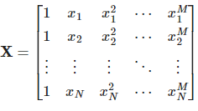
Model order: M+1

Feature matrix:
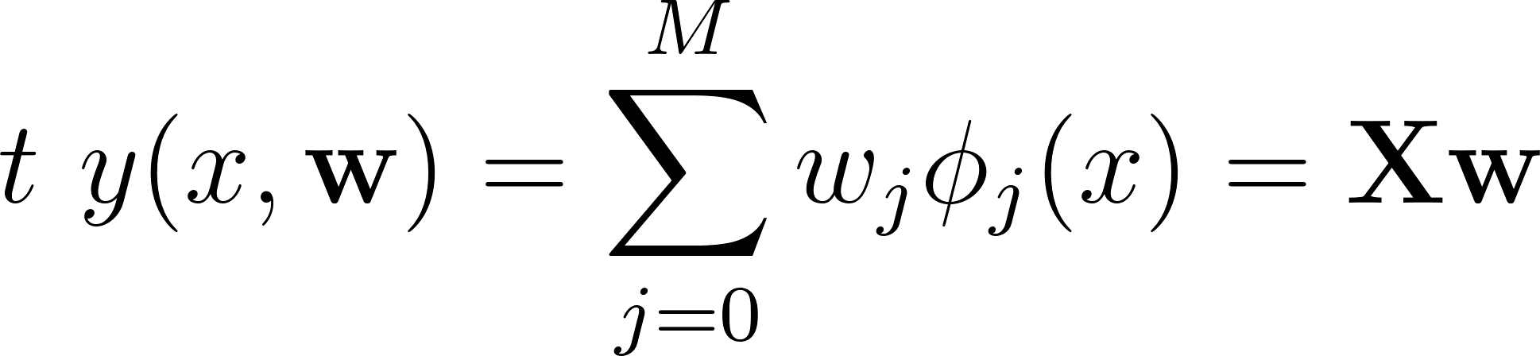
N by M+1

Linear basis model:
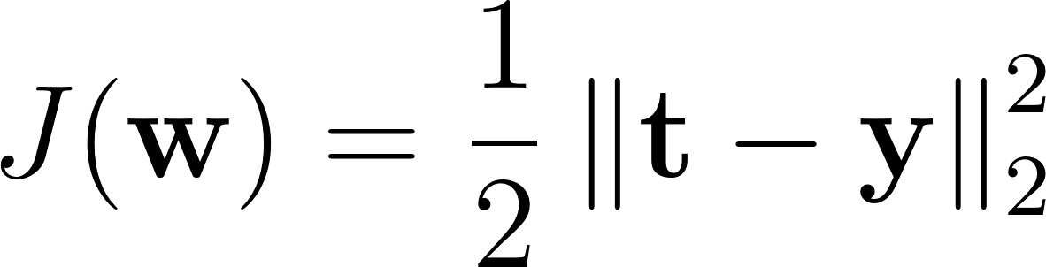
Objective Function, mse:
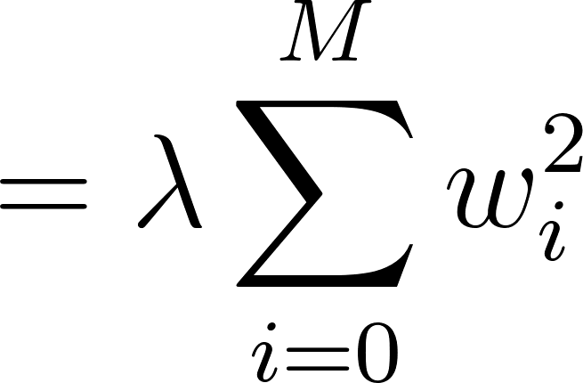
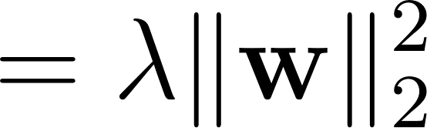
Ridge(L2):
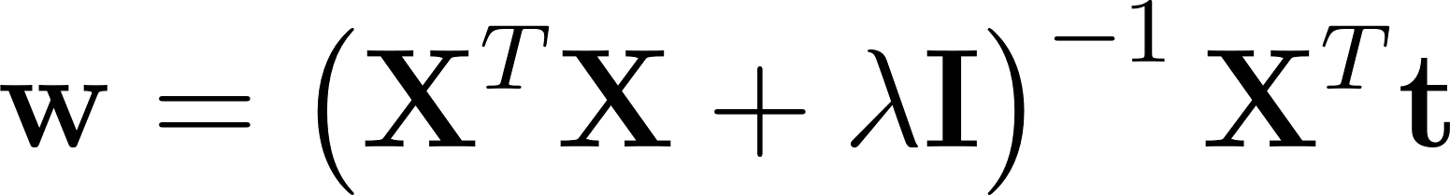

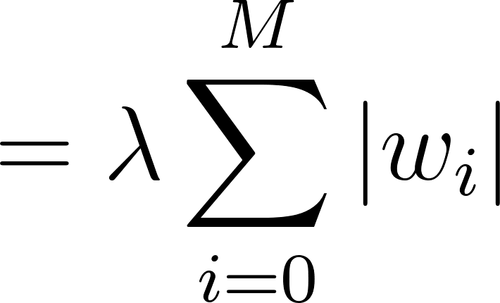
Lasso(L1):
Will approach 0
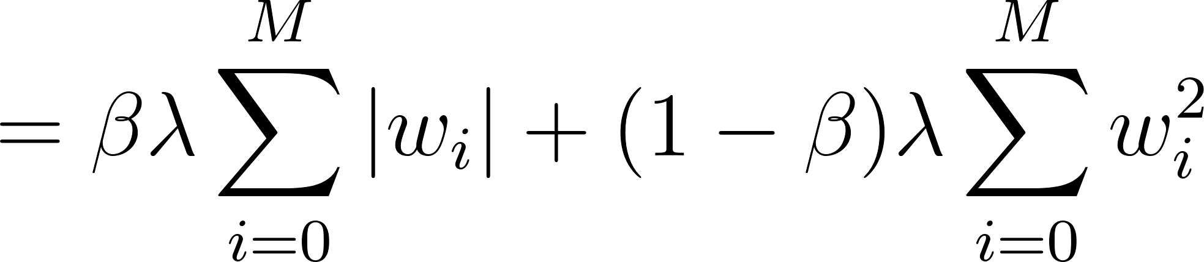
ElasticNet:

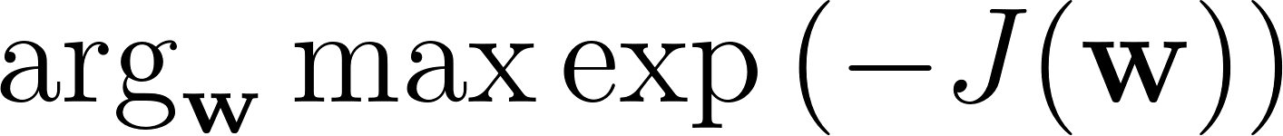
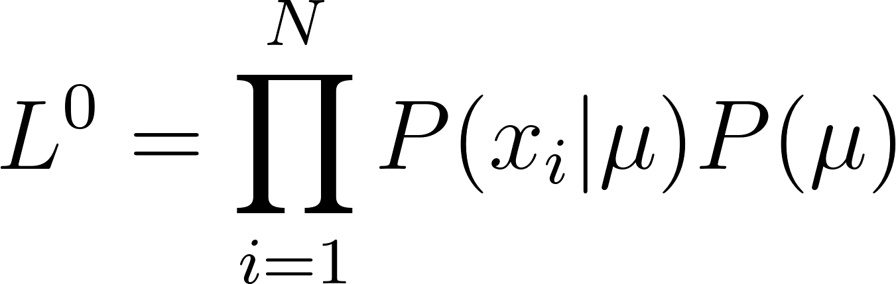
MAP(Bayesian):

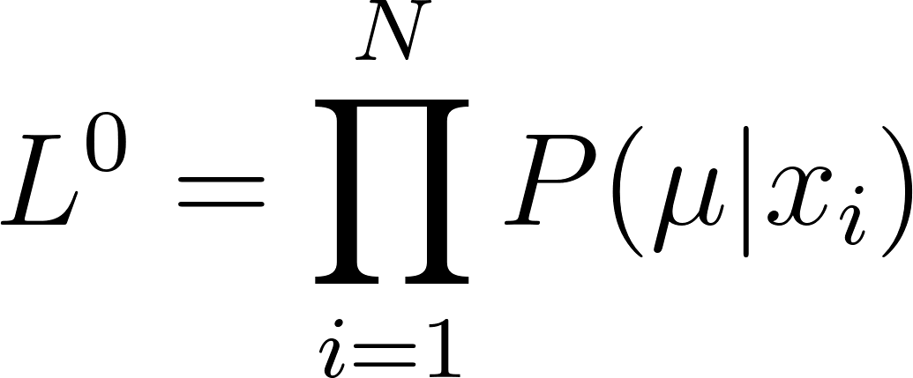
MLE(Frequentist)::

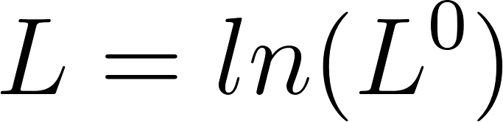
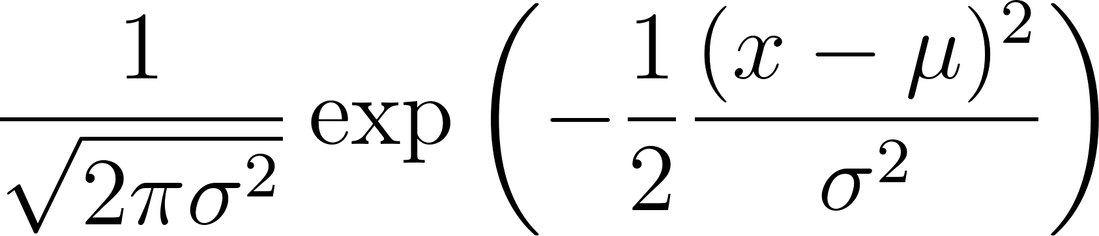
log-likelihood

Univariate Gaussian:
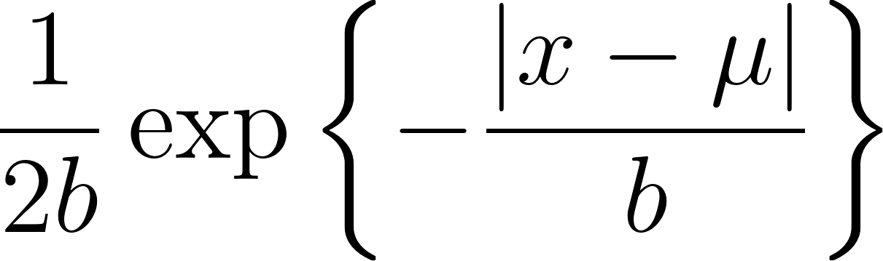

Laplacian:
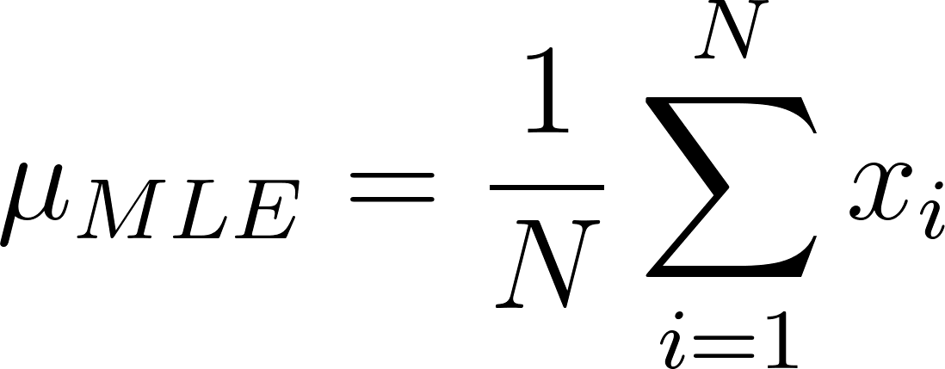
Bernoulli: 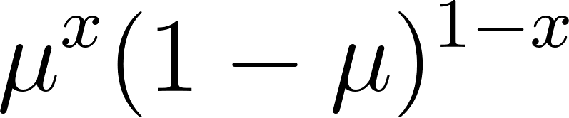 ->

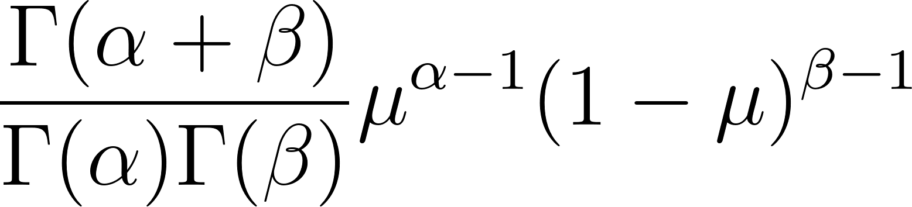
Beta:
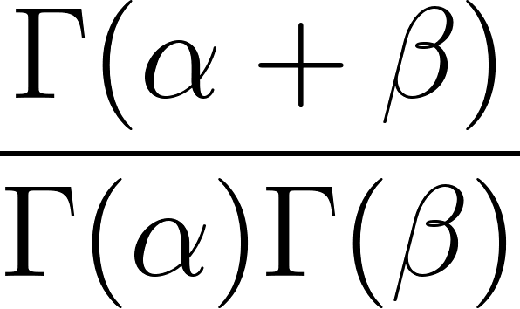
- constant:
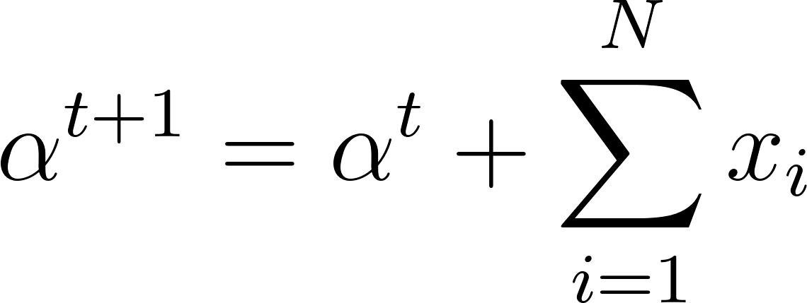

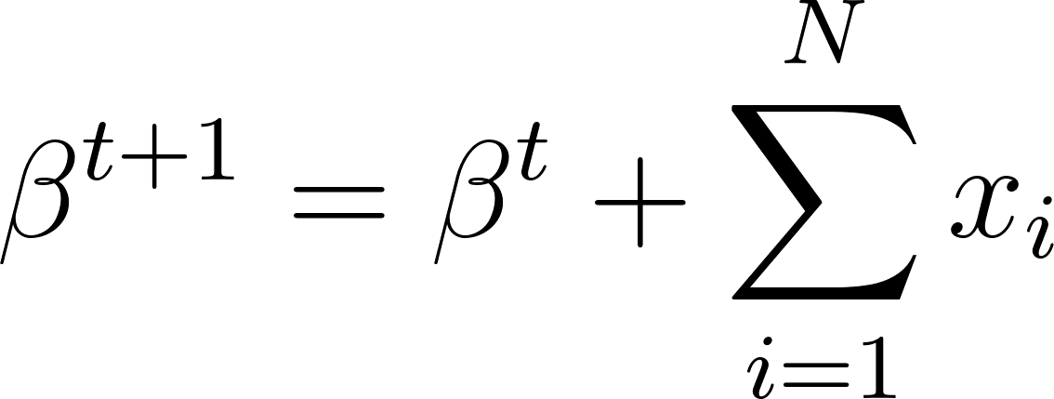

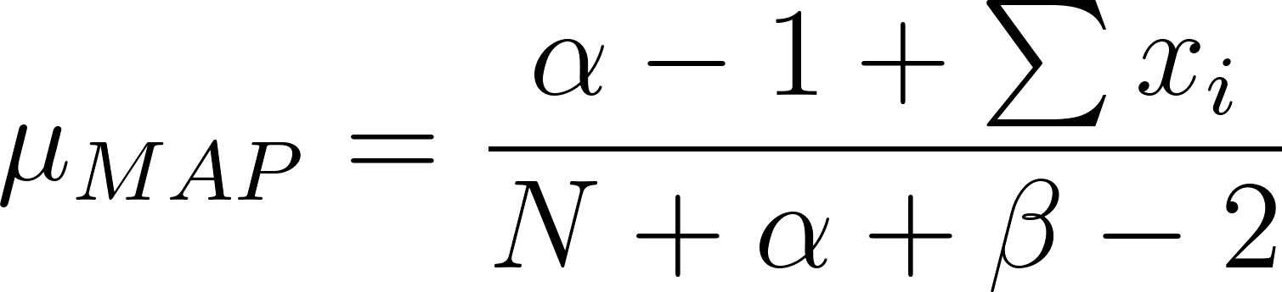
Bernoulli-Beta:(posterior)-(prior)

Multivariate Gaussian: 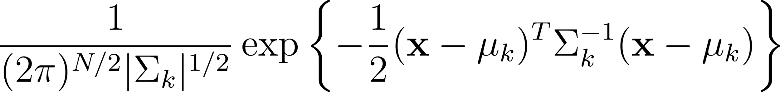
-  is the covariance matrix of k
- 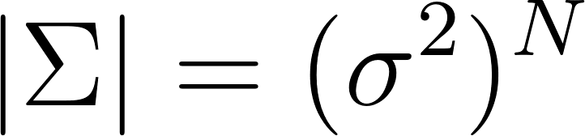 is its determinant of k
- 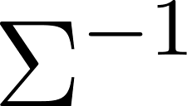 is the inverse of k
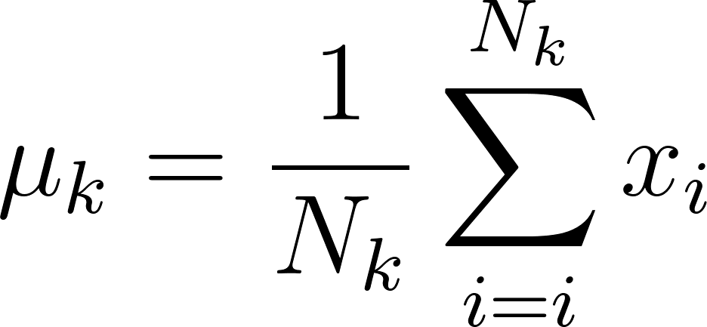
Assuming  is isotropic:

Sample Avg:
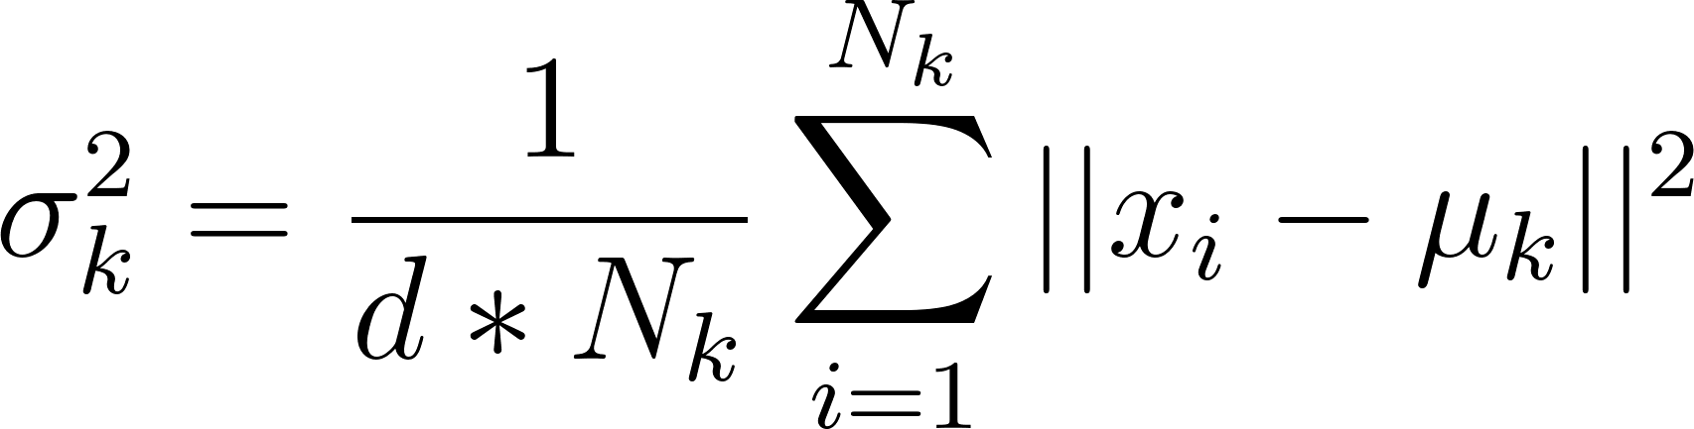
Sample Variance:

Gaussian-Gaussian

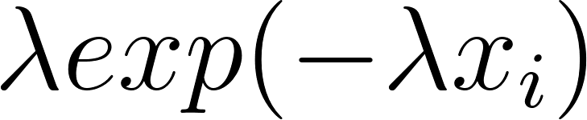
Exponential:
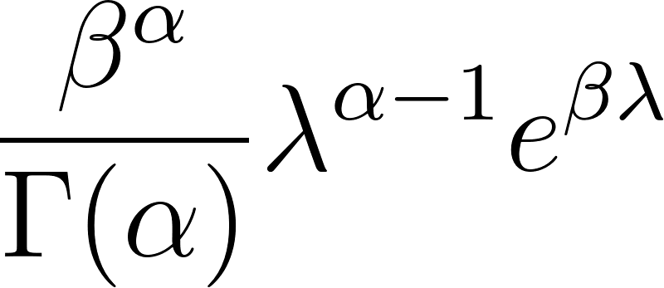
Gamma:
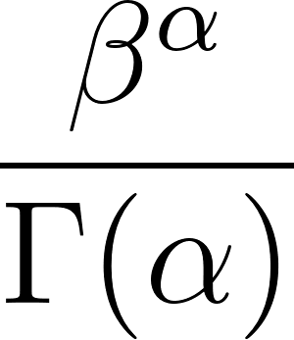
- constant:

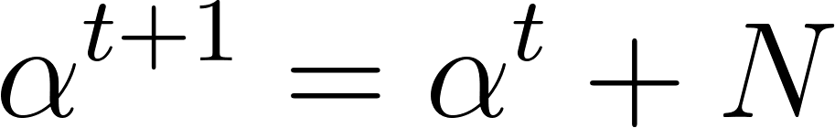


Exponential-Gamma
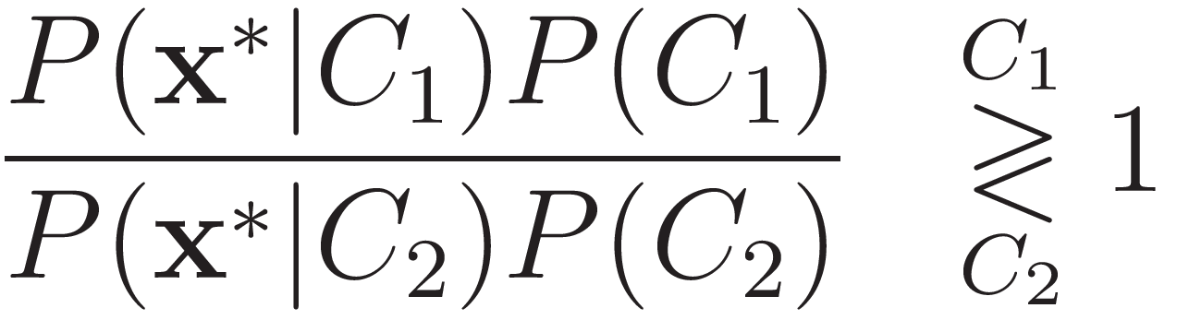
Naive Bayes:

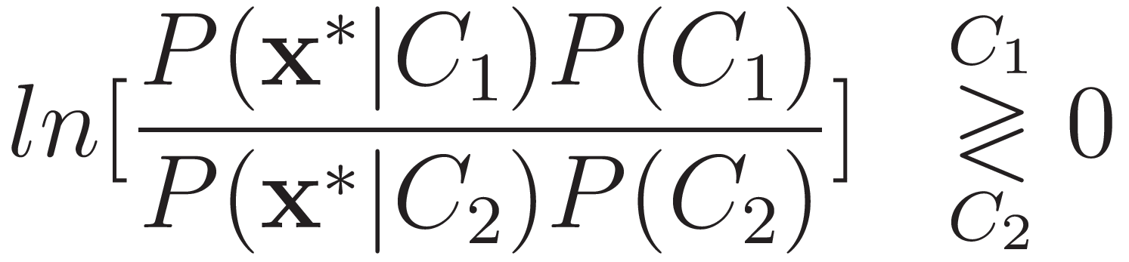
Discriminant Function:
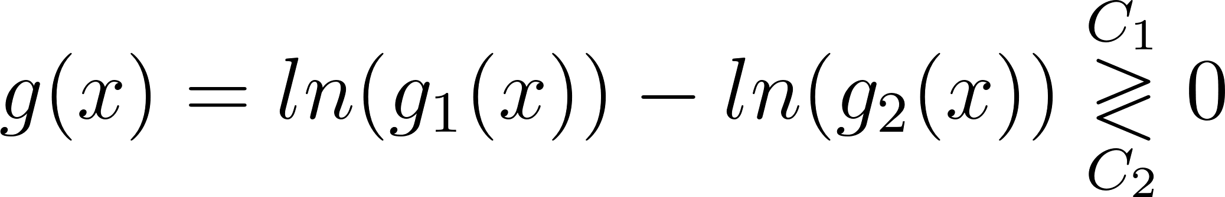

Mixture Models (GMM): 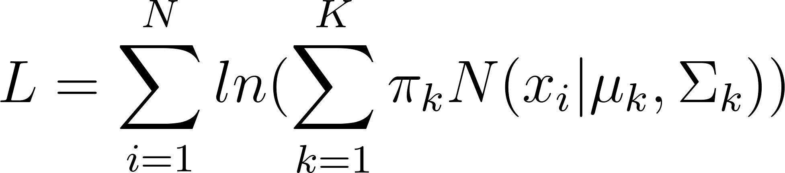
- 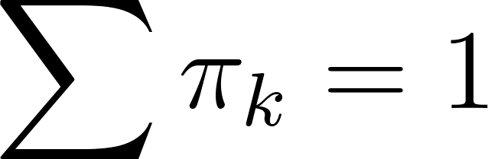

GMM: not sensitive to scaling
Integer encoding: need scaling
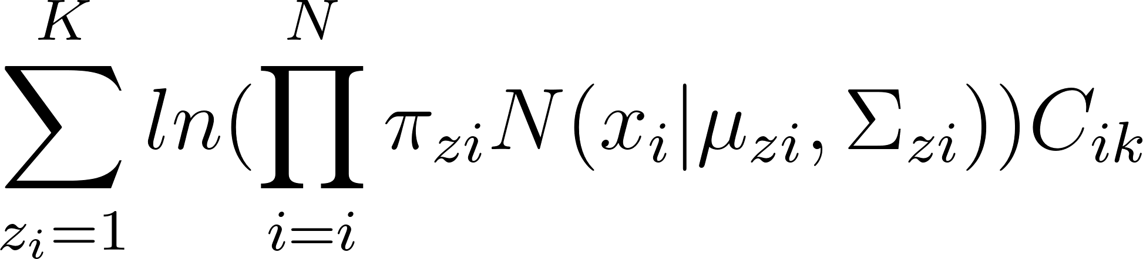
GMM- EM:

- 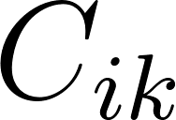 is the membership
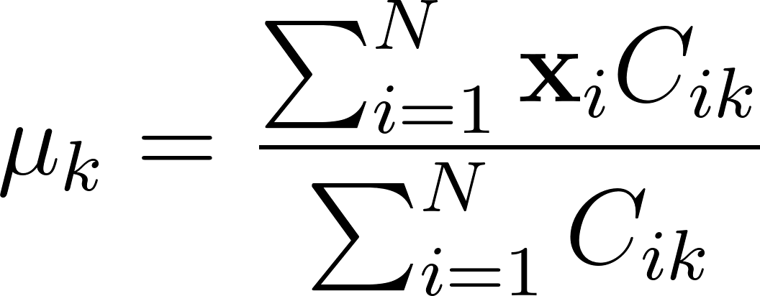

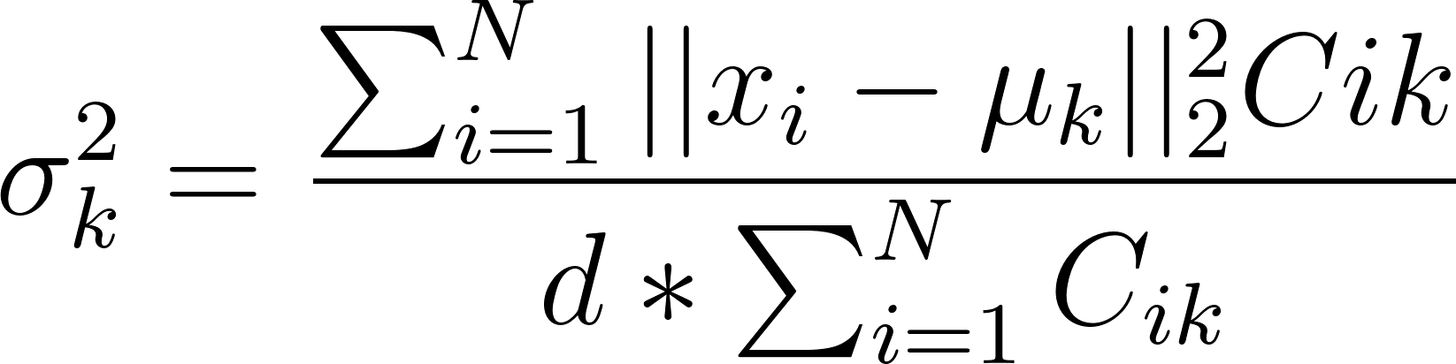

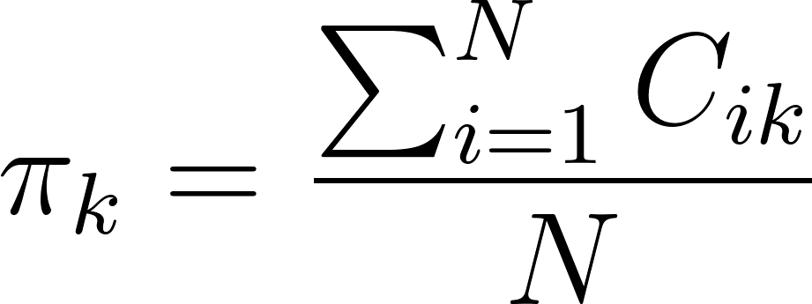

Silhouette Index: 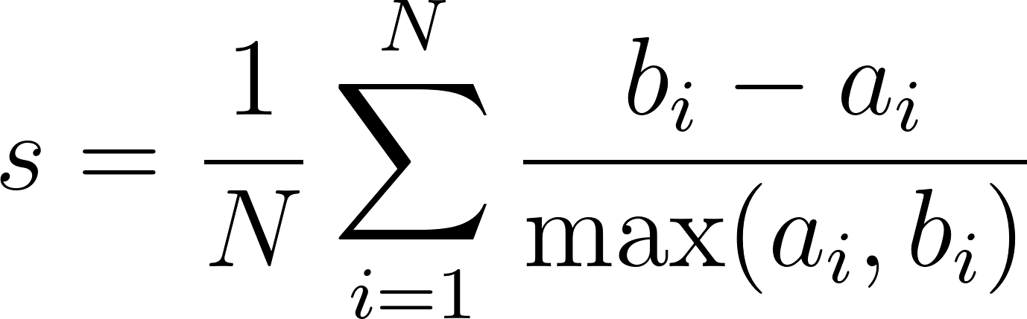
- 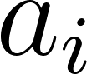 is the average distance of the point 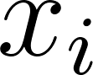 to all the other points of the cluster in which  is assigned to
- 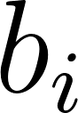 is the average distance of the point  to all the other points in the other clusters.
Rand Index:
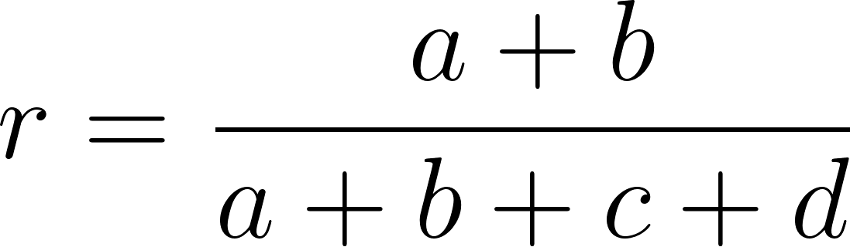
- a is the number of pairs of elements in X that are in the same subset in C and in the same subset in D.
- b is the number of pairs of elements in X that are in different subset in C and in different subset in D.
- c is the number of pairs of elements in X that are in the same subset in C and in different subset in D.
- d is the number of pairs of elements in X that are in different subset in C and in the same subset in D.
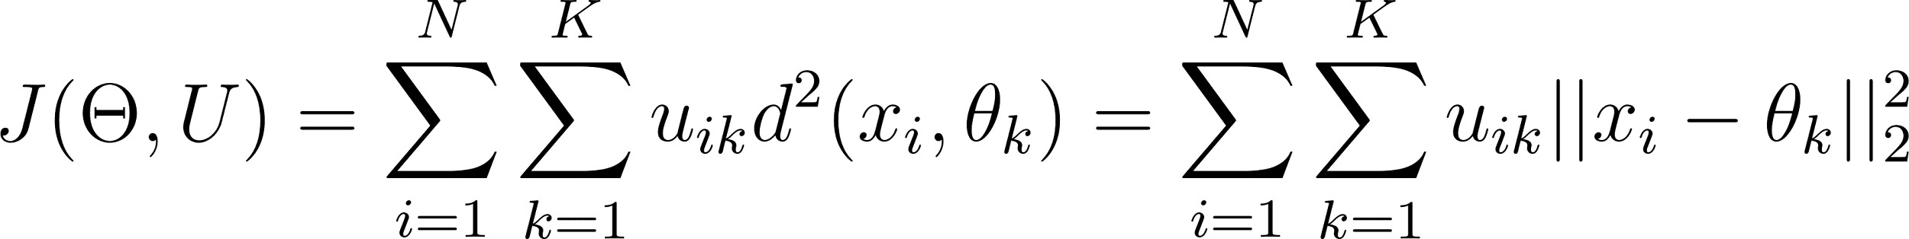
KMeans:

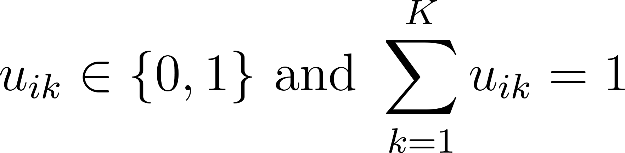
- Hard Assignment:
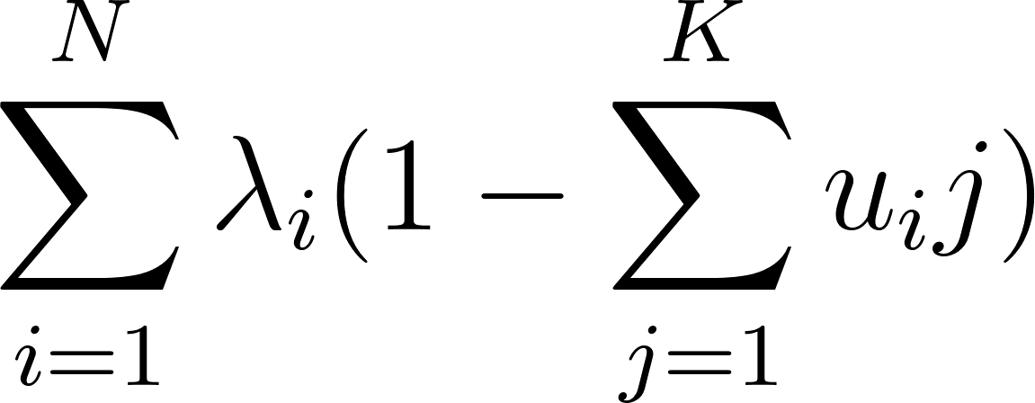
- Lagrange:

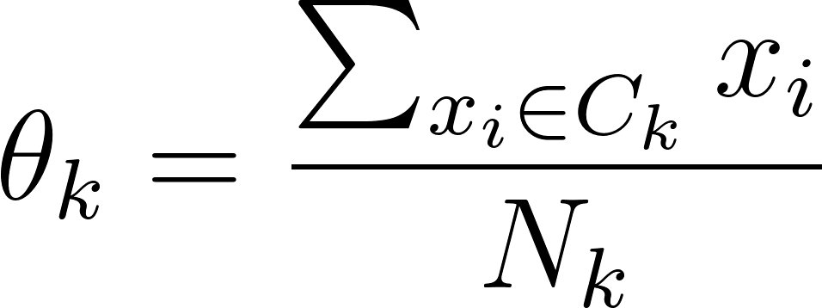
- Mahalanobis Distance(d):
KNN: Choose closest class of highest probability
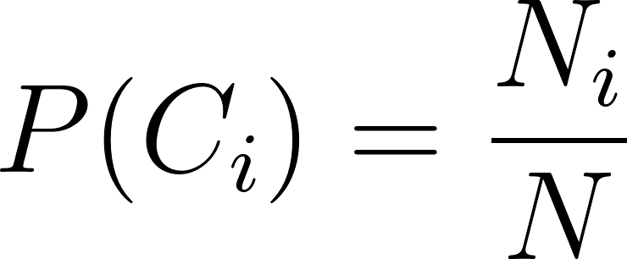
Unweighted:

- 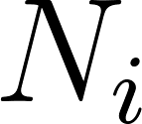 are the neighbors for each class

Weighted:
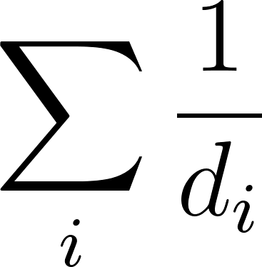
- 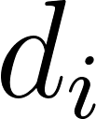 is a distance formula
- Euclidian:
- Mahalanobis:
- City-block:
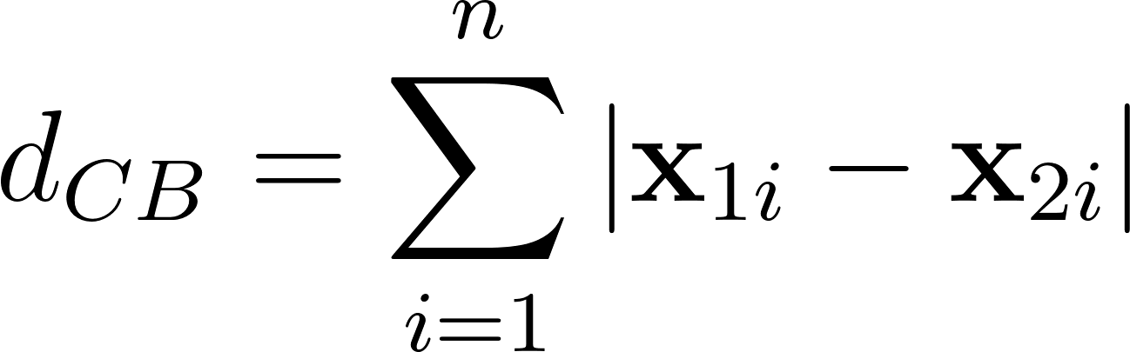
- Cosine: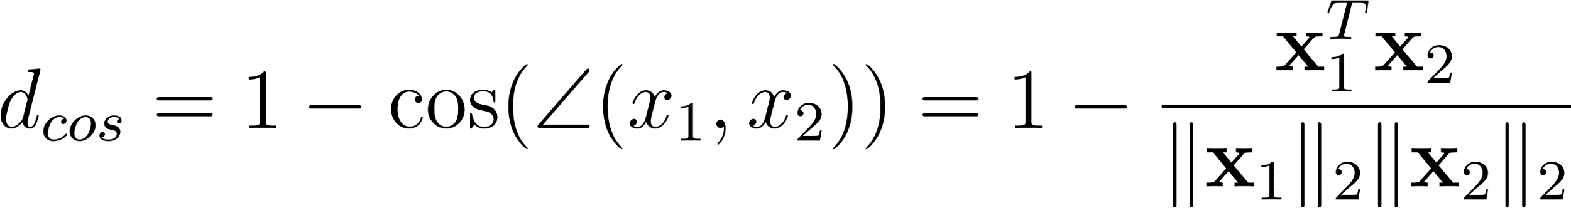
Supervised learning: Data collection, Feature extraction, Mapper function, Objective function, Learning algorithm
Overfitting: more data, Occam’s Razor, Cross-validation, Regularization
MAE: Can mitigate the impacts of outliers
MSE: heavily penalize large error
CV: stratified when imbalance proportion

